PWA Video 12 Fetch Events

<https://www.youtube.com/watch?v=C0vh57N7vM4>

Fetch events happen whenever we try to get something from a server.

Like a CSS,HTML,JS(HTTP request) or image file

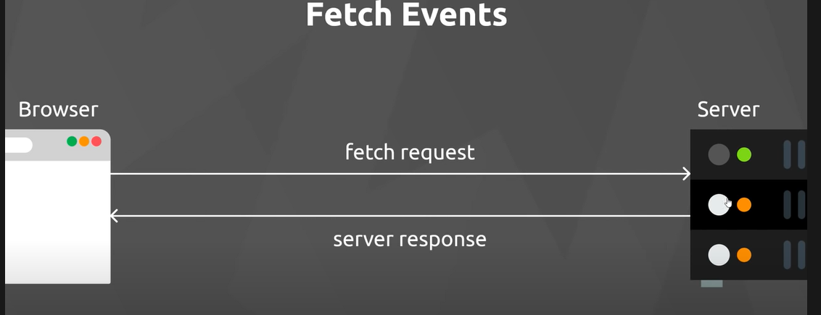

The SW is out there listening for fetch request from app

The SW acts as a proxy between our app and the server

When our app makes a request for an image or css file ect , it goes through service worker and a fetch event is emitted. The service worker can listen for and react to that event .

We can intercept the fetch request and modify it or stop it and return a custom response to the app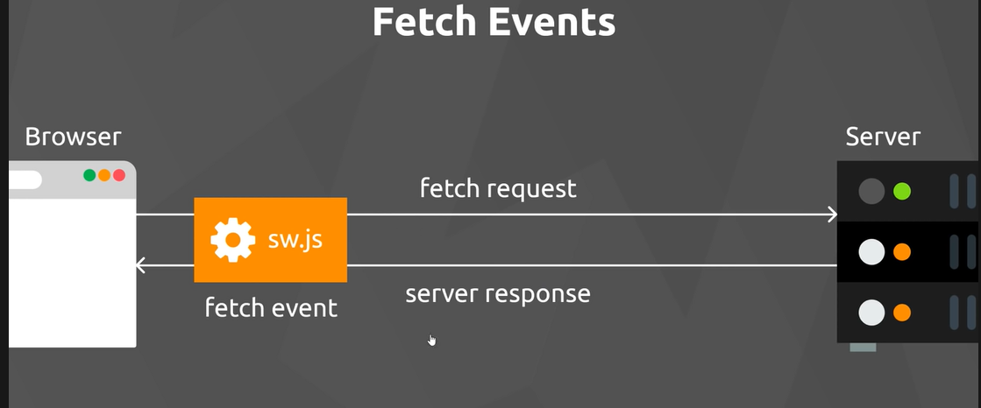

This is how cashed events can be handled – makes the app fast and is at the heart of what Service Workers do.

